Assignment 2 Python and Bash
Q.1 Grade Checker
Take a score as input and print the grade based on the following:
90+ : "A" 80-89 : "B” 70-79 : "C" 60-69 : "D" Below 60 : "F"
here we used a basic if else statement to carry out marks and all.
gardechecker.py
grade = int(input("Enter Marks : "))
if grade >= 90:
print("A")
elif grade >=80:
print("B")
elif grade >=70:
print("C")
elif grade >=60:
print("D")
else:
print("F")

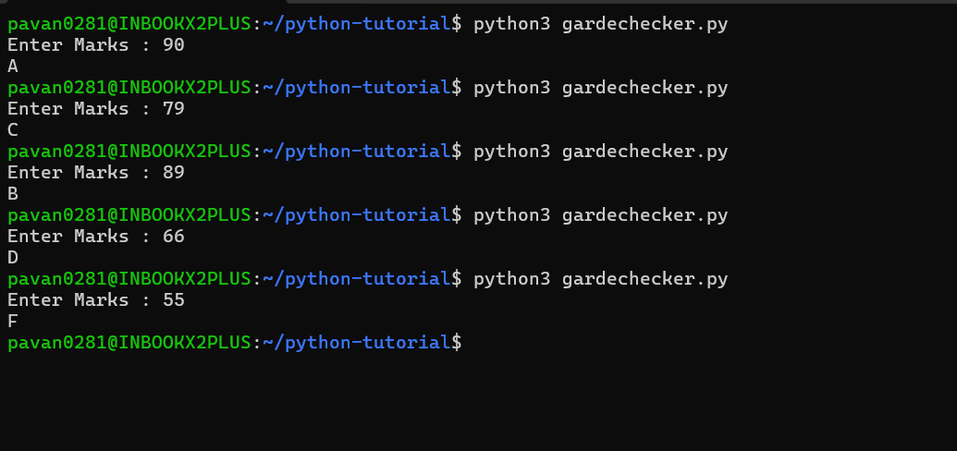
Q. 2 Student Grades
Create a dictionary where the keys are student names and the values are their grades. Allow the user to:
Add a new student and grade.
Update an existing student’s grade.
Print all student grades.
dictonary.py

students = {}
def add_student():
name = input("Enter student name: ")
grade = input("Enter student grade: ")
students[name] = grade
print(f"{name} added with grade {grade}.")
def update_student():
name = input("Enter student name to update: ")
if name in students:
grade = input("Enter new grade: ")
students[name] = grade
print(f"{name}'s grade updated to {grade}.")
else:
print("Student not found.")
def print_students():
if not students:
print("No student records available.")
else:
print("\nStudent Grades:")
for name, grade in students.items():
print(f"{name}: {grade}")
while True:
print("\nMenu:")
print("1. Add new student")
print("2. Update student grade")
print("3. Print all student grades")
print("4. Exit")
choice = input("Choose an option (1–4): ")
if choice == "1":
add_student()
elif choice == "2":
update_student()
elif choice == "3":
print_students()
elif choice == "4":
print("Goodbye!")
break
else:
print("Invalid choice. Please try again.")

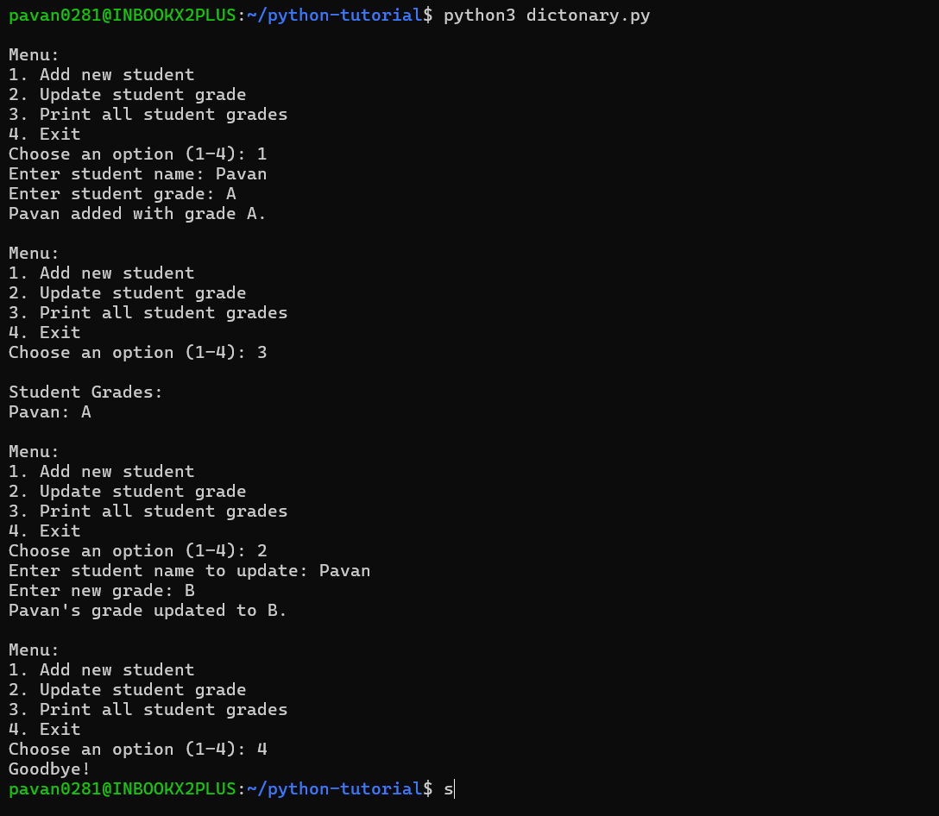

Q.3 Used dictionary and basic operations. Using if else:
3.Write to a File
Write a program to create a text file and write some content to it.
Using file functions like write and open.
file.py
f = open("example.txt", "w")
f.write("hello world\n")
f.write("This is content\n")
f.close()
print("File is created successfully and written some content in it \n")
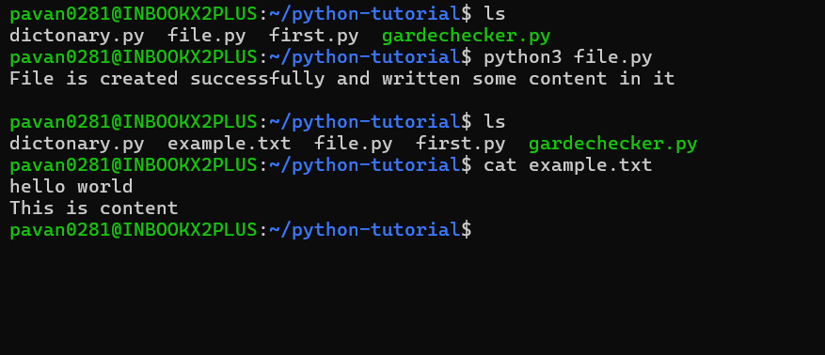

Q.4. Read from a File
We used open in read mode and file.read to read and print to display.
Fileread.py

f = open("example.txt", "r")
data =f.read()
print(data)
f.close()

